Marmara Üniversitesi Mühendislik Fakültesi
Elektrik-Elektronik Mühendisliği

Mehmet Ali Kamalak
150720062

Laboratory Manual EE 3011: Electronics I
Spring 2025

Experiment (2)

Introduction to LT Spice (Part 2)

Page2

Objectives

Experiment (2) Introduction to LT Spice (Part 2)

  - To simulate a first-order low-pass filter circuit using AC analysis.

  - To be able to present results using plots for various circuit variables.

Pre-lab Work
- Before starting this experiment, you need to study the document “Introduction to LT Spice IV with Examples”, by Nicholas Lombardo, Linear Technology, 2015.
- Analyze the circuit in figure 1. In particular, find the frequency response of the transfer function and filter bandwidth.

Circuits
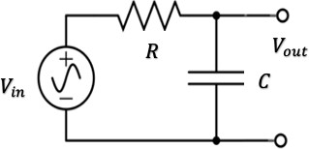
Figure 1: RC low-pass filter.

Procedure
Part (1): AC Analysis.
- Connect the circuit in figure 1. Use the circuit elements values given by the lab instructor. 𝑉_{𝑖𝑛}
is a sinusoidal AC voltage source with frequency 𝑓 and maximum amplitude 𝑉_{𝑚𝑎𝑥}.
- Simulate the circuit using the AC analysis function and generate the transfer function spectrum curve (versus frequency). Use dB scale for the transfer function magnitude and log scale for the frequency.
- Change the value of 𝐶 and observe the simulation curves.

Results and Analysis
Part (1): AC Analysis.
- From your simulations, find the simulated bandwidth of the filter for different values of 𝐶. Record your results in table 1.

Page3

Table 1. Simulated and calculated bandwidth.

Capacitor value | Simulated Bandwidth | Theoretical Bandwidth | % Difference
0.1 µF | 1.59461Hz | 1.59 Hz | %0.29
1 µF | 15.9146Hz | 15.92 Hz | %0.03
10 µF | 158.256Hz | 159.15 Hz | %0.56

- Comment on the results in table 1.

The results in Table 1 show that the simulated and theoretical values are very close to each other. Comparing with the theoretical formula, the experiment confirms that as capacitance increases, the cutoff frequency decreases, and as capacitance decreases, the cutoff frequency increases.

- If the output of the circuit is taken across the resistor instead of the capacitor, what kind of a filter is obtained? Explain your answer and support it using simulation results.

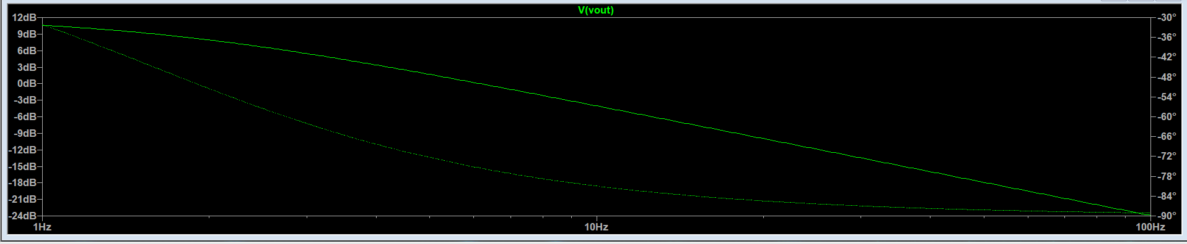
When the output is taken across the resistor, circuit acts as a high pass filter. The voltage decreases at low frequencies and remains stable at high frequencies.
Page4

Lab Assignment
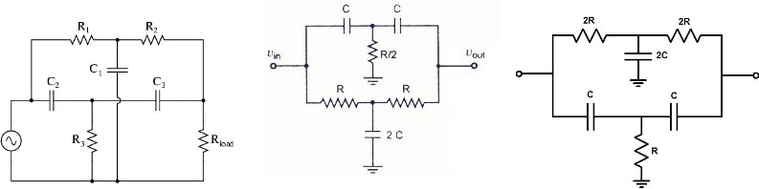

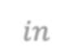
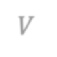



𝑉𝑖𝑛
𝑉𝑖𝑛
𝑉𝑜𝑢𝑡
𝑉𝑖𝑛
R₄
𝑉𝑜𝑢𝑡
𝑉𝑜𝑢𝑡

Circuit 1 Circuit 2 Circuit 3

- The lab instructor will assign one circuit to you with appropriate elements values.
- Connect the circuit using the circuit elements values given by the lab instructor. 𝑉_{𝑖𝑛} is a sinusoidal AC voltage source with frequency 𝑓 and maximum amplitude 𝑉_{𝑚𝑎𝑥}.
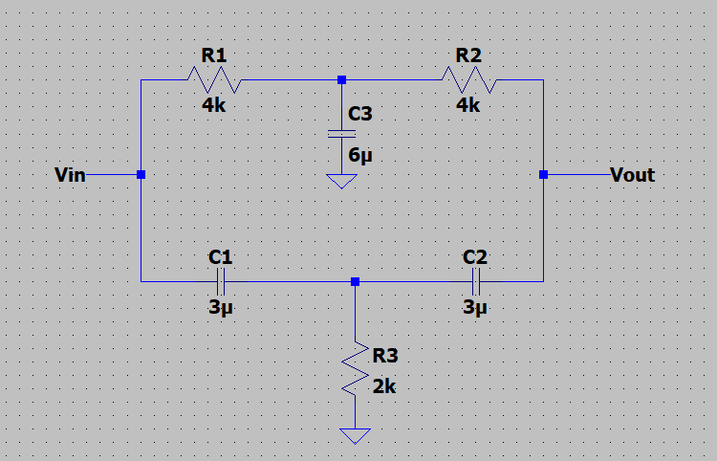

- Simulate the circuit using the AC analysis function and generate the transfer function spectrum curve (versus frequency). Use dB scale for the transfer function and log scale for the frequency.

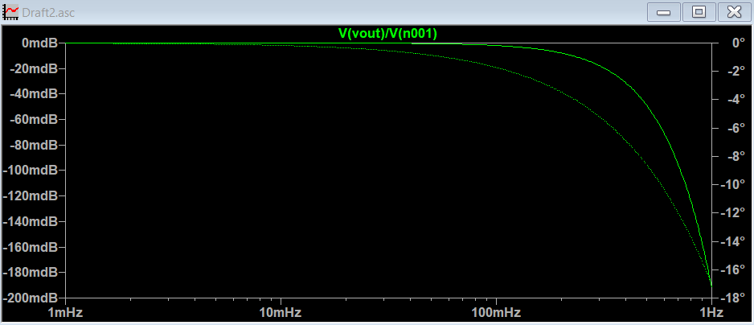

- From your simulations, find the simulated bandwidth of this filter circuit.
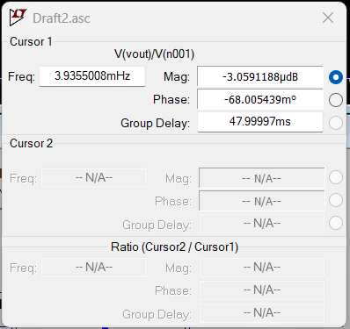
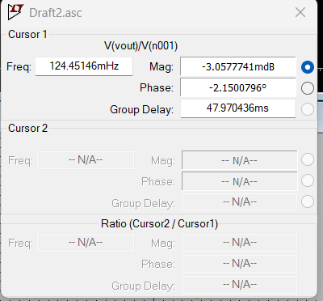

- Change the value of the circuit elements (one at a time) and observe the simulation curves. Write your conclusions regarding the effect of these elements on the circuit bandwidth. Can you come-up with a formula for the bandwidth in terms of 𝐶 and 𝑅?

R1= 8k, R2=8k, R3 = 4k, C1= 3µ, C2 = 3µ, C3= 6 µ

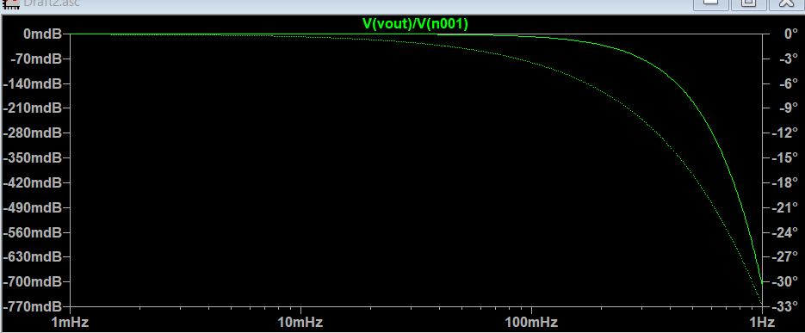

R1= 8k, R2=8k, R3 = 4k, C1= 6µ, C2 = 6µ, C3= 12µ

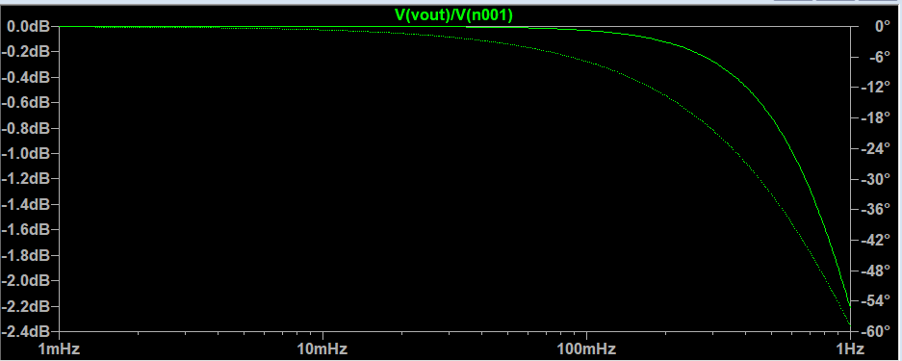

R1= 4k, R2=4k, R3 = 2k, C1= 6µ, C2 = 6µ, C3= 12µ

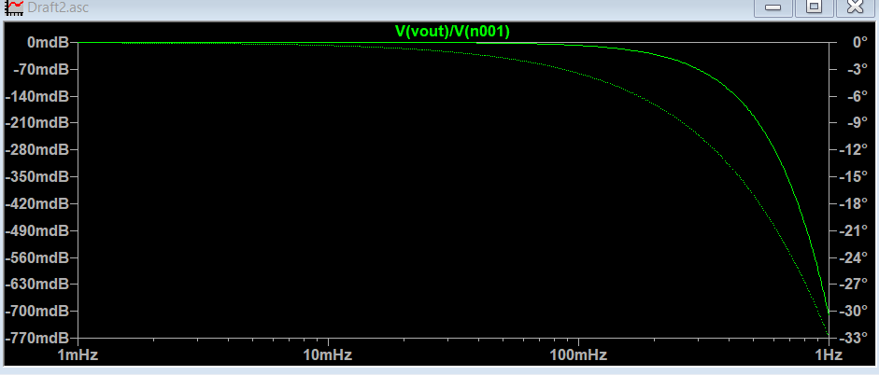

- What kind of a filter is this circuit? Explain.

The circuit acts as a Band-Pass Filter because it allows only a specific range of frequencies to pass while blocking both low and high frequencies. The width of this band depends on the values of R and C components, meaning the filter’s range can be adjusted by changing these elements.

